EXPERIMENT-4

CSMA/CD

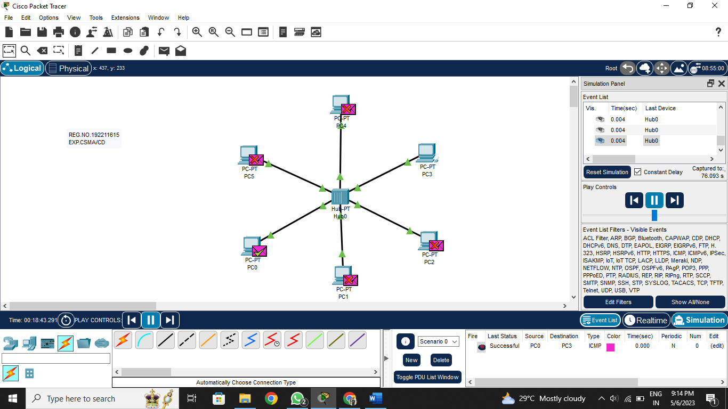

CSMA/CA

